Bart Perry “Like a Good Neighbor” State Farm Scholarship
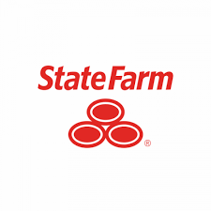

Name _________________________
College Choice _______________________
Planned Major: ____________________________
GPA __________________________ ACT Score _______________________
Address __________________________________________________________
Phone Number and email address __________________________________________________
Activity Record: (student organizations, extracurricular and community activities, etc.)

Honors and Awards: (school, church or community)

*attach resume sheet if more space is needed
State Farm’s logo is “Like a Good Neighbor State Farm is There”. Write a short essay stating what this means to you and how it applies to your own life and future plans.

Return completed applications to by Wednesday, April 1, 2020.
Bart Perry
1000 Forrest Pl Suite 1
Pell City, AL 35128-2307

