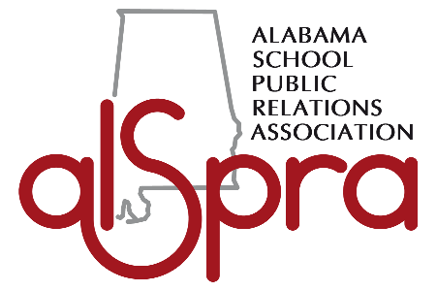 ALABAMA SCHOOL Public Relations Association SCHOLARSHIP
______________________________________________________________________________

2016 Scholarship Eligibility Requirements

The Alabama School Public Relations Association is a statewide coalition of professional school communicators. ALSPRA offers financial support to students who plan to enroll in an Alabama college or university after high school graduation and who plan to seek a degree in communication, public relations or a related field. Student members who are eligible may apply for the education scholarship program offered at the beginning of each calendar year and awarded at the annual ALSPRA Conference in mid-Spring.

CANDIDATES
The candidate must be interested in pursuing a public relations major, communication major or emphasis track at a university or college within the state of Alabama. The candidate must be a high school junior or senior at an Alabama public school with a minimum grade point average of 3.0 on a 4.0 scale.

An official transcript from your high school must be submitted with your application. Applicants who participate in a school organization related to journalism, public relations, communication, student media or marketing or who are members of a local, state or national public relations organization are preferred.

APPLICATION
Please type or fill out the student scholarship application in black or blue ink (print legibly). The application must be accompanied by your transcript, résumé, photo and response to an essay question related to the public relations field.

Select one of the two questions presented below for your essay. Choose the question that best suits your interests in public relations. The essay must be original, typed, double-spaced and no longer than two pages, approximately 800 words.

- What do you think is the most important issue or trend affecting PR today and why? Give real-world examples.
- Over the last 10 years, how has the PR profession changed and where do you see the profession going in the next 10 years and why?

SCHOLARSHIP SELECTION PROCESS
The scholarship winner will be selected by an ALSPRA committee and notified by mid-February. ALSPRA will award one $500 scholarship and present the winner with a certificate in recognition of his or her achievement. The winner will be honored during the Annual ALSPRA Conference luncheon in mid-Spring. In addition, the winning essay may be published on ALSPRA’s website. In addition to the winning essay, student photograph may also be published on the ALSPRA website and will not be used as a criteria in the judging process. The final decision will be left up to the discretion of the scholarship committee.

DEADLINE & SUBMISSION DETAILS
The deadline for the 2016 ALSPRA Student Scholarship is January 15. Mail your application to: ALSPRA, P.O. Box 2093, Montgomery, AL 36102-2093 or email it to alabamaschoolpr@gmail.com . Application can also be found on the ALSPRA website at: http://www.alspra.org/. Once received by ALSPRA, your essay and application materials become property of the Association and will not be returned.

ALABAMA SCHOOL PUBLIC RELATIONS ASSOCIATION SCHOLARSHIP
P.O. Box 2093, Montgomery, AL 36102-2093

PERSONAL DATA

Name_______________________________________________________________________________
Last First Middle

Date of birth _________________________________________________

Permanent Address ___________________________________________ ________________________
Street City
_______ ________________ ________________ Best Phone Number ______________________
State Country Zip Code

E-Mail Address: ________________________________________________________________________

ACADEMIC INFORMATION
College or University You Plan to Attend ____________________________________________________
Major You Plan to Pursue ________________________________________________________________
Expected Enrollment Date ________________________________________________________________
***
High School Attending __________________________________________________________________
High School Address ___________________________________________________________________
_____________________________________________________________________________________
Current GPA __________________ Expected Graduation Date __________________________________
***
School Activities (offices held, committees, honors, etc.) ________________________________________
_____________________________________________________________________________________
_____________________________________________________________________________________
_____________________________________________________________________________________

Extracurricular and Volunteer Activities (community groups, professional organizations, etc.) ____________________________________________________________________________________
__________________________________________________________________________________________________________________________________________________________________________
_____________________________________________________________________________________

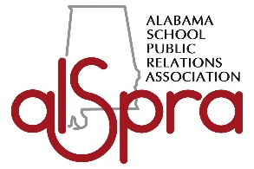
PLEASE READ AND SIGN THE FOLLOWING STATEMENT
I certify that the information given in this application is correct. Should I be awarded the scholarship, I agree to give strict attention to my academic duties and the regulations of my school and to use this scholarship for an educational purpose.

I understand the eligibility requirements for the ALSPRA Scholarship and agree to furnish with this application the required essay and any additional documents required for a final decision in granting a scholarship award under this program. I understand that my application and likeness may be used in promotional materials by the Alabama School Public Relations Association.
_____________________________________________________________
Signature of Applicant
____________________________________________________________
Date

